LAB Brief

Course – Cloud Computing on AWS

Steps to be followed:

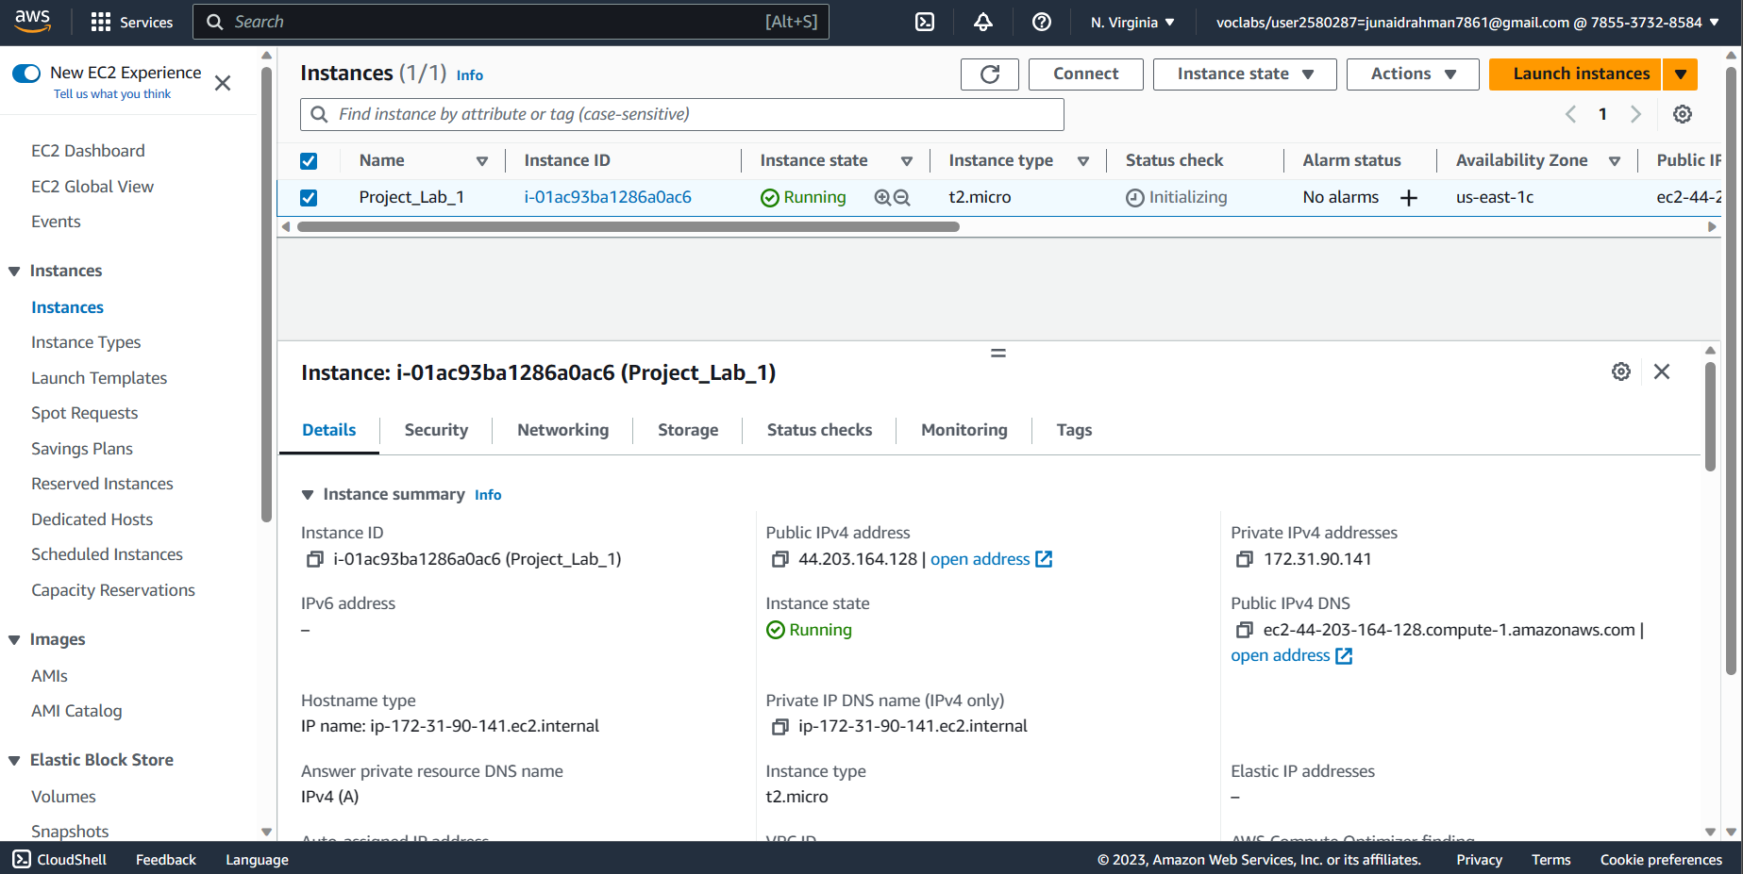1. Get an ec2 instance using the 7-step workflow & SSH in it

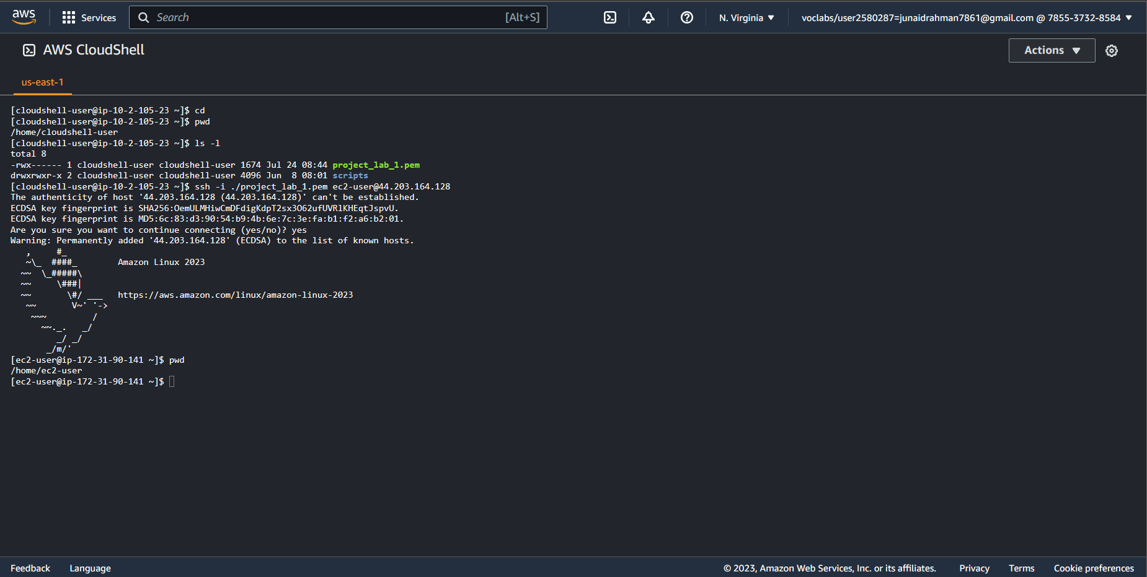

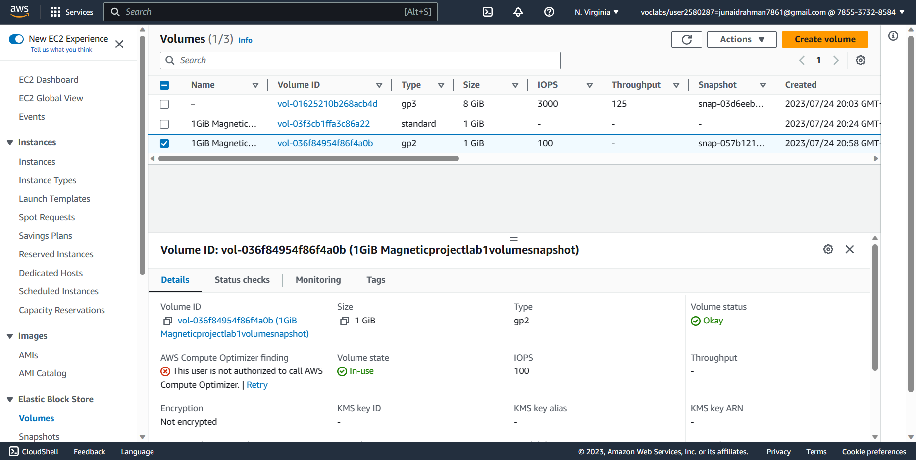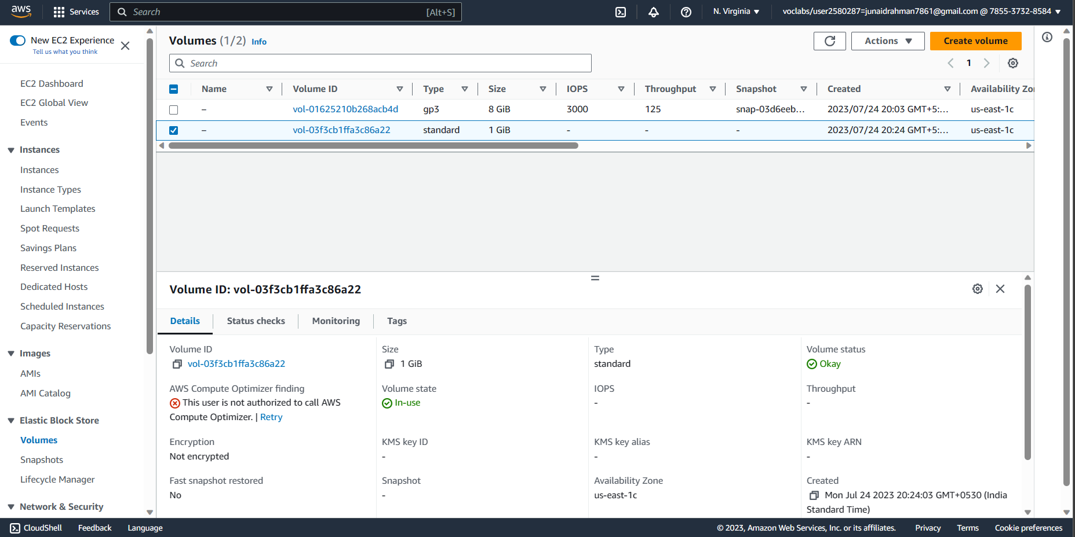2. Grab an additional disk

3. Create volume without and with snapshot and attach the created instance and perform the operations

4. Attach, format, mount to an EC2 instance

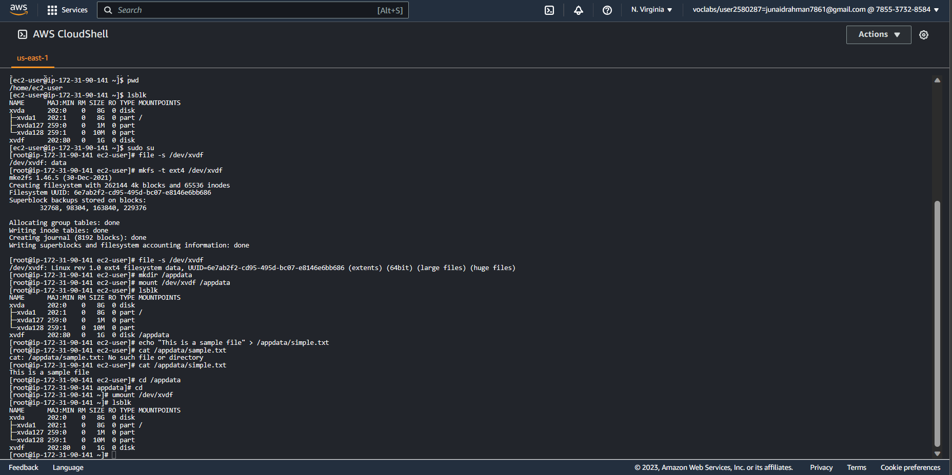5. Able to create snapshots and apply to volumes

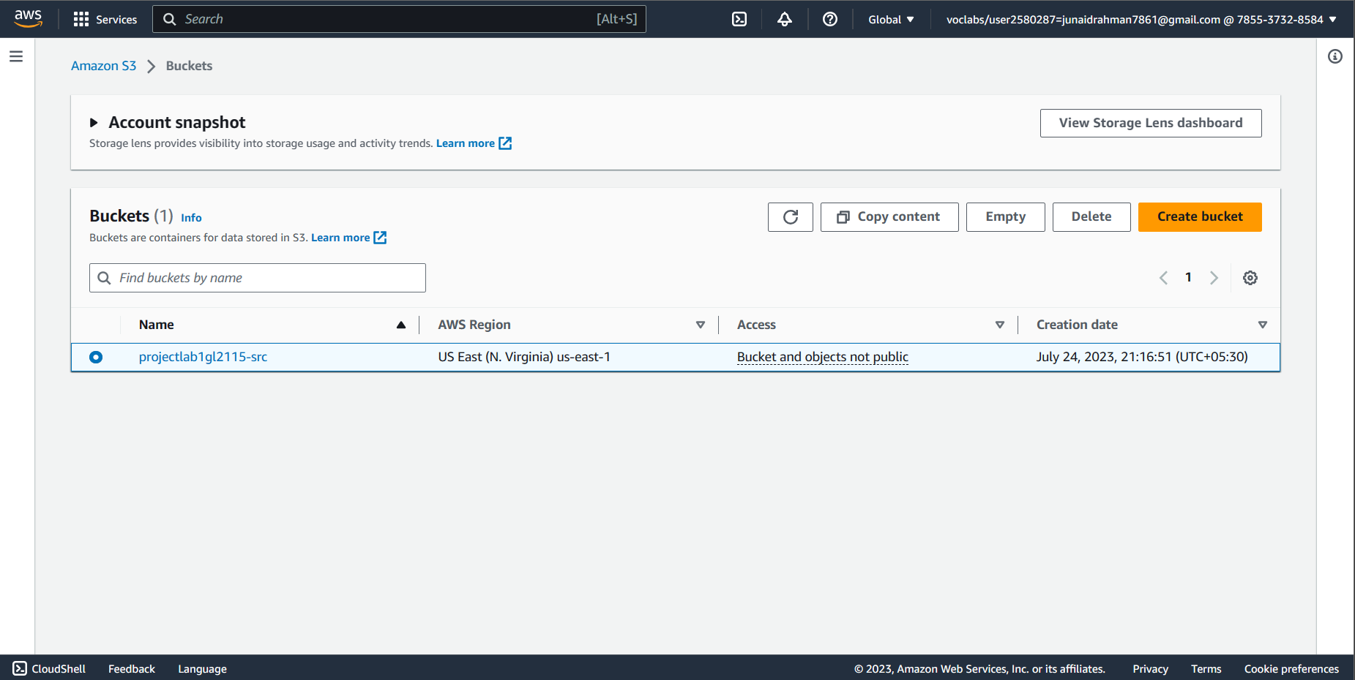5. Use s3 using the console and via CLI

a. creates a source s3 bucket and upload local files from machine and list the bucket and its content

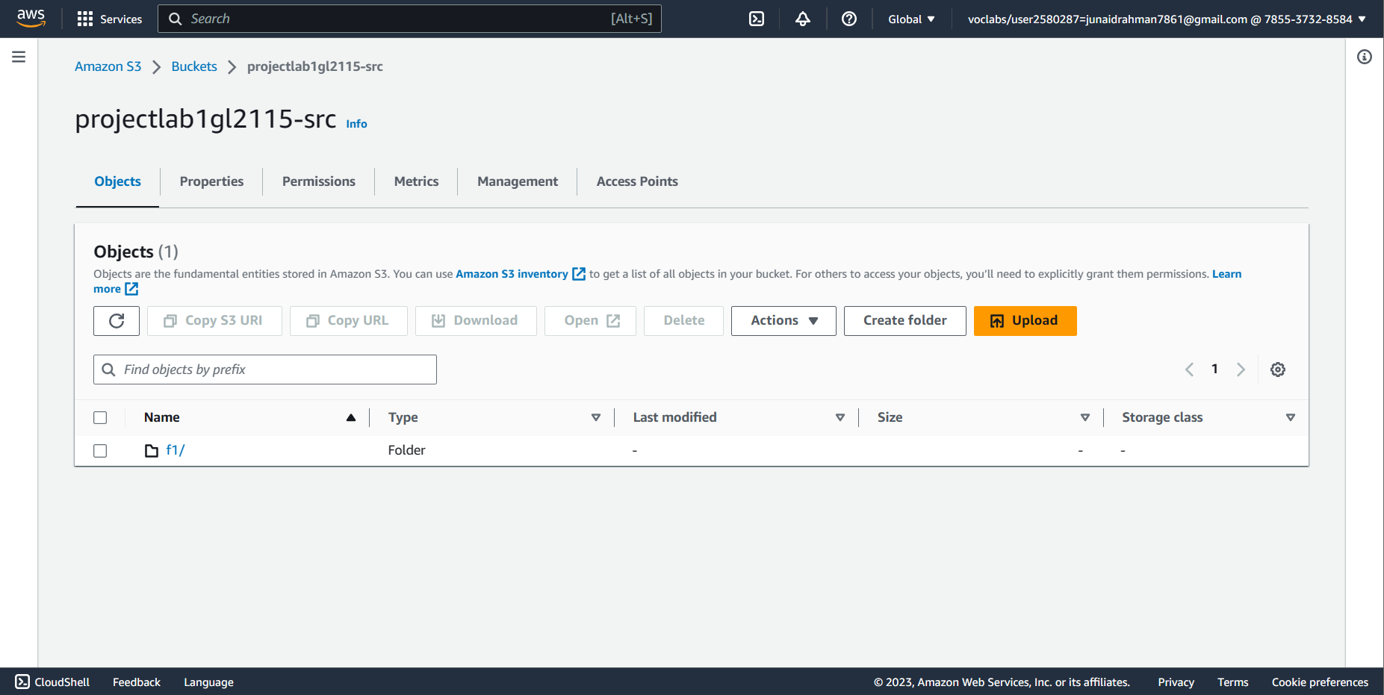

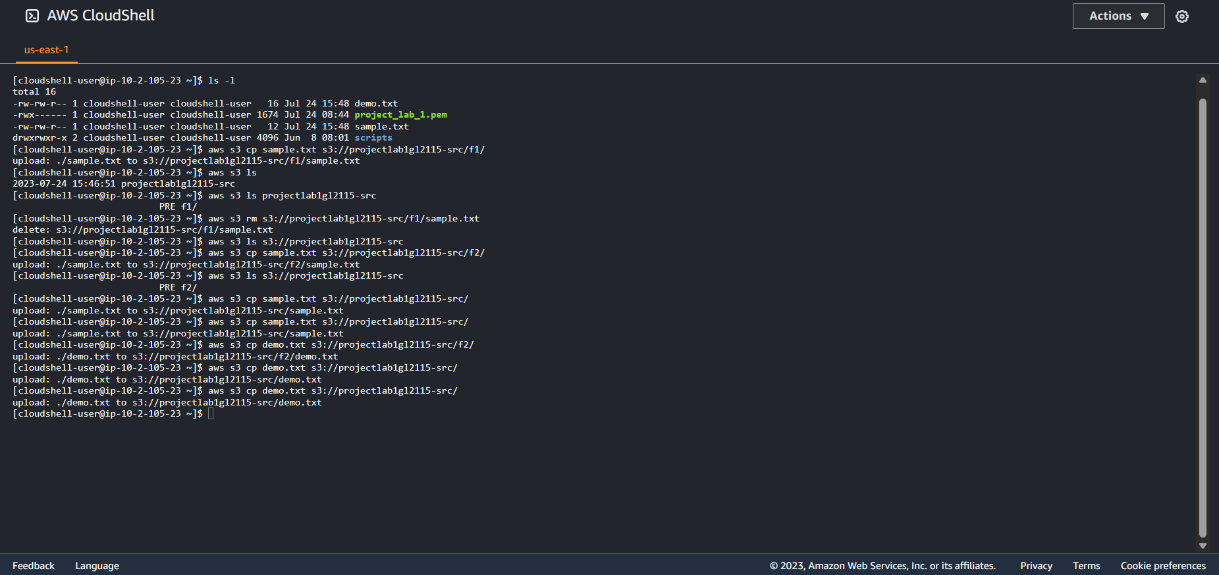b. performs the operations in the cloud shell

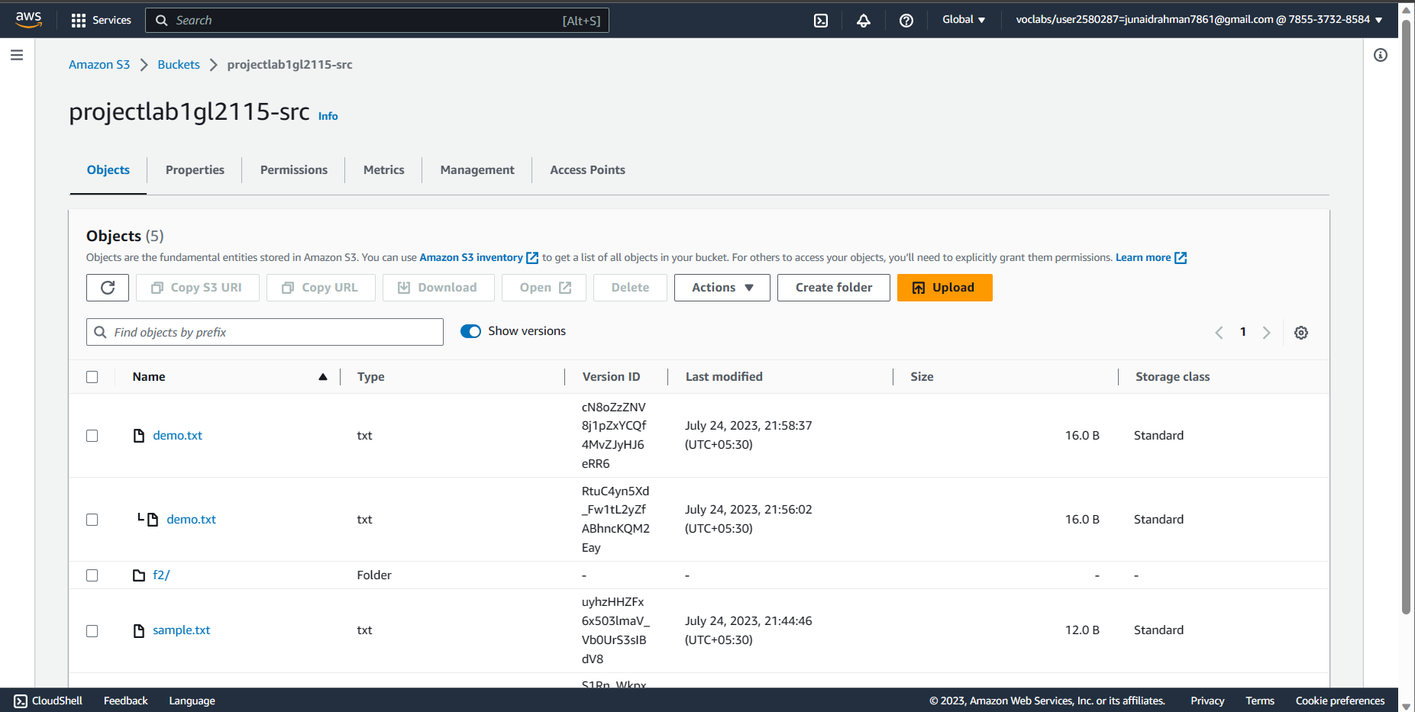c. Enable versioning of the bucket and perform add the existing files again.

d. Enable cross region replication and create a new destination s3 bucket to perform replication operation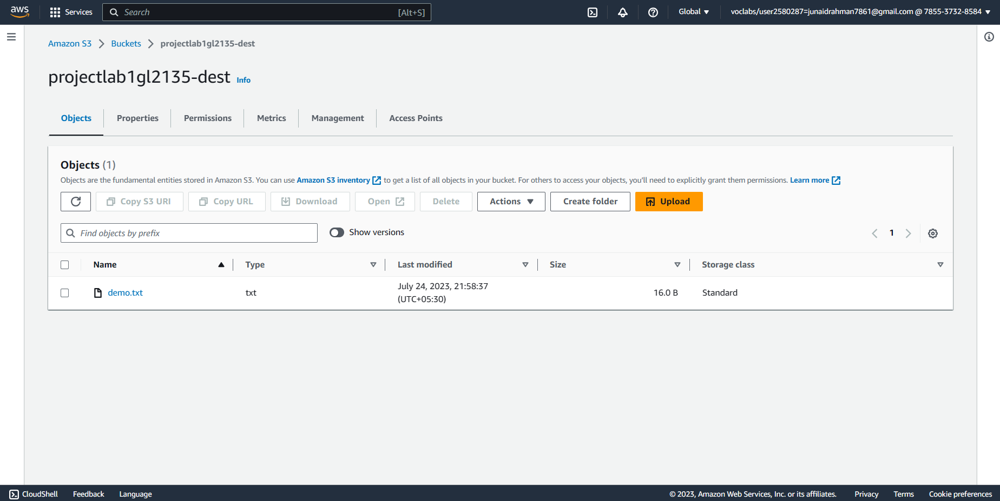

Observations:

After adding new files to source bucket via cloud shell or CLI, observe that the destination bucket also gets affected via the replication rule.

The destination bucket has option to replicate the source only with the rule of allow to entire bucket or any specific content in the bucket.

To delete files from both the buckets we have to enable delete markup option.

Adding versioning will help us to understand that files added in the bucket are having delete marker option as well as which will tell us that latest edited date and time for the contents.